**SOP for masking WL Manchester Diffusion data with masking_WL_datav2.m**

This code was written to split the combined uterine wall + placenta mask provided in the Manchester training data set to two distinct uterine wall and placental masks. This code is thrown together from a few other scripts and functions so is not the neatest, and sometimes the variables and structure might not make much sense, but this was produced against the clock!

**Requirements**  
MATLAB 2016 or later  
Image processing toolbox

*Masking_WL_datav2.m  
partition_placentavWL.m  
snap_pla_to_uterWL.m*

**Set up**

A lot of this set up is hard coded due to time constraints

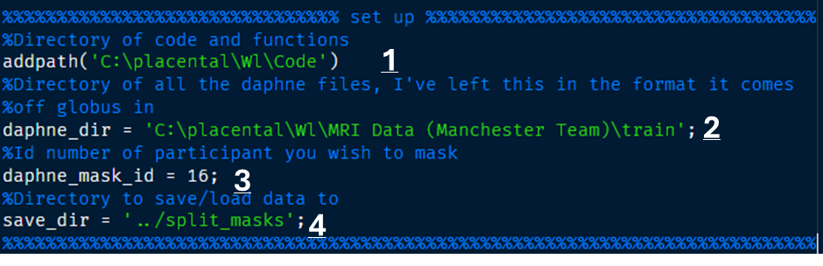

Refer to numbers above:  
  
1. The location of this code and relevant functions  
2. The location of the daphne data, kept in the same format as downloaded from globus (i.e. a separate folder from each visit)  
3. daphne_mask_id – the participant ID (e.g. 14, 16, 52 N.B. DO NOT include the v2/v3, this script will allow you to make all visits in one go)  
4. Where to save the outputs to

**Running the code**

First this code will check if the save directory exists and try to make it (if it already exists this will produce a warning, but it is fine).

Second It looks in the save directory to see if masks already exist, if they do it will load them, allowing you to continue masks, or edit old masks without redrawing them all.

Then the GUI will appear:

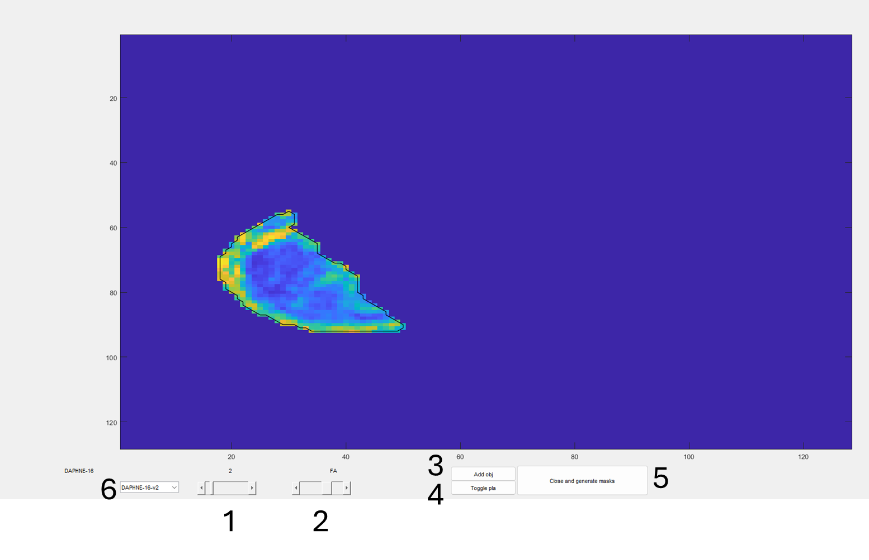

Guidelines for GUI use:

1. Slice slider, flicks through slices and displays the slice number above
2. IVIM parameter and label, can change between all the anisotropic IVIM fit data
3. Add a dividing line to separate the placenta and uterus (see below)
4. Toggle placenta, defines which side of the mask is uterine wall, and which is placental (see below)
5. Close and generate .nii.gz masks for all scans from this participant
6. Drop-down for switching visit number (see below)

**3. add obj**

When you press add obj it will change your cursor and you can start dividing the placental along the uterine wall:

Initially click near where the uterine wall and placenta meet, then you can draw along the uterine wall until you reach the end, then press the enter key to complete the dividing line. The ROI will automatically snap to the uterine wall mask so you don’t have to be voxel-perfect with you ending points, the code will sort them out.

After drawing you can edit the roi by dragging the points, or if you double click at some point along the line it will add an extra point. If you want to completely restart your line ROI, just click add obj again and it will delete the old one and let you draw a new one.

You can flick between different parameter maps while editing the line but not drawing it.

**4. toggle pla**

This serves two purposes:

Once the dividing line is completed the ROI will go green along one edge:

You want this green line to be along the uterine wall, so if you press toggle placenta (sometimes it needs two presses, I haven’t fixed this yet)

The green line is now along the uterine wall. This button also serves as a way to update the dividing line (for example if you move the first or last point) just toggle the green line to the wrong side, then back to the correct side and it will update the ROI. I will try to fix these issues before the hackathon!!

**6.Drop down menu**

All scans from this participant should be in the drop down menu, for example:

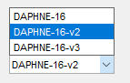

When you switch scan it automatically saves all the lines you’ve drawn and sides you’ve picked to a file in the save directory called:

*DAPHNE-ID-V#_mask_file.mat*

Where ID and V# are the participant ID and visit number. The easiest way to save is to switch to a different visit, but this will not generate the .nii masks, you have to press the button 5 labelled ‘close and generate masks’ which will close the GUI, save the mask files, and generate niftis of the placenta and uterine wall for all scans for that participant and output them to you *save_dir*.

If you then wish to load the same participant in future, the code will check your *save_dir* for any mask_files and load them, so you can check or edit your dividing lines in future without having to redraw them, and then you can regenerate the masks.

I’d recommend checking the masks after you make them, they might not match the exact orientation but check the uterine wall/placenta are the correct way round, and that nothing weird has happened. If it has don’t worry, provided when you load the GUI and see the dividing line it is in the correct place, we can fix everything else after!